**SITE FURNISHING DESIGN GUIDELINES**

1. **Porous Unit Pavers**
   1. Porous Unit Pavers
      * Manufacturer: Hanover Architectural Products
      * Thickness: 4 inches
      * Size and Shape: 3 ¼ inches by 18 inches
      * Finish: Natural
      * Color: Charcoal
   2. Aggregate Setting/Leveling Bed: Sound crushed, washed stone or gravel.
   3. Drainage Geotextile: Nonwoven, needle-punched geotextile manufactured for subsurface drainage applications.
   4. Aggregate Fill for Porous Paving: Graded, sound, washed, crushed stone or gravel. Type - Trap Rock. 3/8 x #4



1. **Curb Ramps**
   1. Cast-In-Place Replaceable Tactile – Warning Tiles
      * Manufacturer: ADA Solutions, Inc.
      * Material: Molded glass and carbon-fiber reinforced polyester
      * Size: 24 inches by 48 inches rectangular panel
      * Dome Spacing: 2.35 inch spacing in square pattern
      * Mounting: Embedded tile we-set into freshly poured concrete
      * Color: Black



1. **Concrete Pedestrian Pavement**
   1. Concrete pavement is to be used as the primary surface for pedestrian circulation throughout the campus. The intent is to provide walks that are safe, durable and cost effective.
      * Walks are a minimum 6 ‘ wide and are the City of St. Louis standard mix with a light broom finish perpendicular to flow of traffic.
      * Pavement tolerances shall comply with ACI 117: Elevation within ¼ inch; Thickness – plus 3/8 inch and minus ¼ inch; Level Surface within ¼ inch over 10 feet; Contraction Joint Depth – plus ¼ inch; Joint Width – plus 1/8 inch.
2. **Concrete Pavement Joints**
   1. Concrete pavement joints are intended to reduce pavement cracking. Expansion and contraction joints within cement concrete pavement. Joints between cement and asphalt pavement. City of St. Louis Board of Public Service Standard Specifications.



1. **Bollards**
   1. Bollards may be placed on campus in order to protect pedestrians from vehicle traffic and to discourage vehicles from entering pedestrian spaces.
      * Performance: Protective stainless-steel bollards capable of resisting vehicle loads in accordance with ASCE 7
      * Design: 36” high stainless steel post cover over steel pipe filled with concrete and cast in reinforced concrete footing.
      * Stainless Steel: Free of surface blemishes and complying with ASTM A 666 – sheet and flat bars, ASTM A 312/A 312M – schedule 40 steel pipe, and ASTM A 554 – round tubing. Finish to be satin #6 buffed.
      * Hardware: stainless steel set screws.
      * Concrete material: Comply with Section 501 “Concrete” of the MODOT Standard Specifications and proportioned according to ACI 301.



1. **Benches and Tables**
   1. Benches
      * Manufacturer: Landscape Forms Benches
      * Austin is the style of benches used on campus.
      * Backed style benches is 24”x72”x33”
      * Backless style bench is 22”x72”x18”
      * Benches with freestanding/surface mount supports ship with glides which may be removed for surfacing.
      * Material: Aluminum body and powder coat dusted.

* 1. Tables
     + Manufacturer: Landscape Forms for Tables and Chairs.
     + Various styles of tables and chairs used throughout campus. Depending on the area and landscape.
     + Catena and Steelhead Metal Tabletops – black
     + Verona perforated chairs
     + 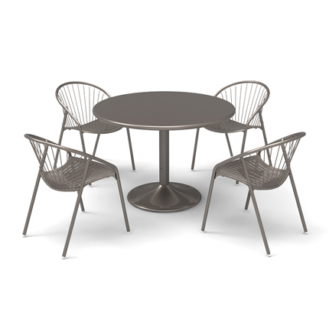Charlie Table – perforated
     + <https://www.landscapeforms.com>

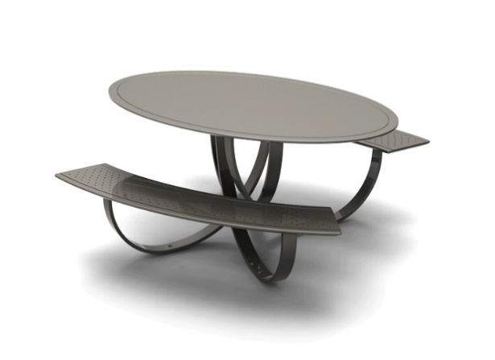

1. **Waste Receptacles**
   1. Two different styles of waste receptacles used on campus. Landscape Forms-Chase Park, and Bigbelly.
   2. Chasepark
      * Decorative metal trash receptacle
      * Round cylinder with side openings for depositing trash. Inner container is rigged plastic. Designed to be removable and reusable. Service access on the side with a self-latching hinge.
      * Receptacle height 39 inches and he width 24 inches. Material cast in aluminum with Silver powder coat finish.
      * <https://www.landscapeforms.com>

* 1. BigBelly
     + Smart,solar powered comacting model.
     + High Capacity(HC5)
     + Built in Comactor
     + Senses & communicates Fullness
     + On-board GPS for Geolocation
     + Enclosed design with hopper
     + Durable & street tough design
     + **A trash can on the sidewalk

       Description automatically generated with low confidence**bigbelly.com

1. **Bike Racks**
   1. Manufacturer: Madrax, Heavy Duty Challenger
   2. Specs:
      * 2-3/8” OD Steel Tubing
      * Powder coated black
      * 88 ¼”+1” width
      * 36”+1/2” Height
      * 3-7 loop
      * 3-9 bike Capacity
      * Website- madrax.com

1. **Fences**
   1. Manufacturer: Tuffbilt, Cascade
   2. Material: Aluminum, powder coated black to resist rusting.
   3. 6ftx8ft
   4. Low Maintenance, easy to install
   5. tuffbilt.com

1. **Pedestrian Lights**
   1. Cast aluminum twin or single luminaire assembly with LED retrofit light optics.
   2. Light fixtures and their brackets shall be mounted to a cast iron post with tapered,16-flute shaft and base.
   3. Top of post should be 3” diameter x 3” high tenon(s) for luminaire mounting.
   4. One post shall have four L-type anchor bolts. With a door in the base for anchorage and wiring. Also a grounding screw provided.
   5. 5 year warranty period for LED module. 1 year warranty for pole.
   6. Integral LED Driver with LED retrofit module. Semi-cutoff, directional LED module optical assembly.
   7. 50,000+ hour useful life LED rating.
   8. 4,000 degree Kelvin color temperature.
   9. Drip irrigation system when required by application.
   10. Model # F262, manufactured by Bosmere Inc.,Concord, NC (phone: 704-784-1608)

1. **Planters**
   1. Decorative Planter
      * Dry limestone decorative planters.
      * Durable in all seasons, resistant to cracking.
      * Shall have 3” drainage/irrigation cavity in bottom of planter.
      * Manufactured: Classic Garden Ornaments. Website-charlotte@longshaow.com
      * Sizes 3’, 4’, or 5’ diameter custom style
      * Color St. Louis Gold in natural stone finish.

* 1. **Decorative Pedestrian Light Planter**
     + Prefabricated metal hanging baskets
     + 18” diameter with coco mat liner and painted black.
     + Hanging baskets shall be provided with drip irrigation via pedestrian light pole internal distribution.

THIS PAGE INTENTIONALLY LEFT BLANK